NAME:Akhil
REG.NO: 192211894
SERIAL NO: 10
COURSE NAME: FUNDAMENTALS OF
COMPUTING
COURSE CODE: CSA5779
SLOT NAME:D

EXPERIMENT: 1
EXPERIMENT NAME: GENERATION OF NUMBER SERIES
PROGRAM:
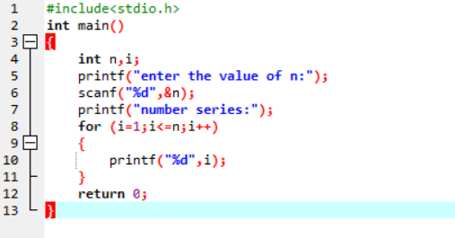
OUTPUT:
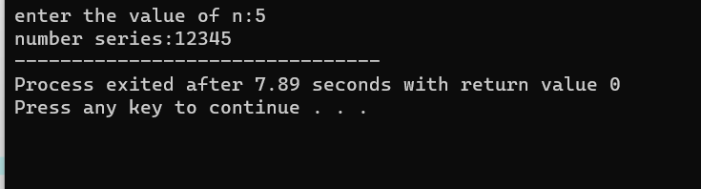

EXPERIMENT: 2
EXPERIMENT NAME: GENERATION OF EVEN NUMBERS
PROGRAM:
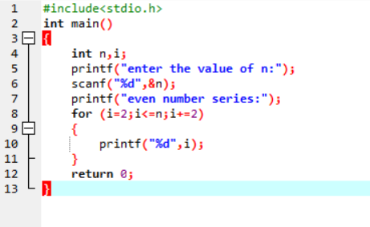

OUTPUT:
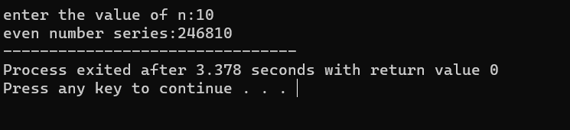

EXPERIMENT:3
EXPERIMENT NAME: GENERATION OF ODD NUMBER SERIES
PROGRAM:
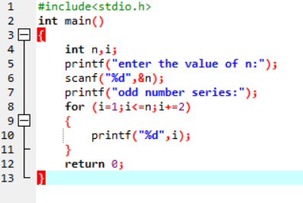
OUTPUT
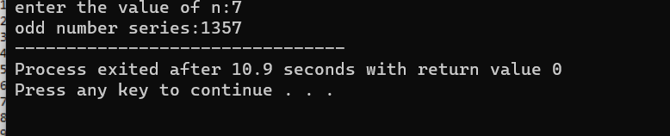

EXPERIMENT:4
EXPERIMENT NAME: GENERATION OF FIBONACCI SERIES
PROGRAM:
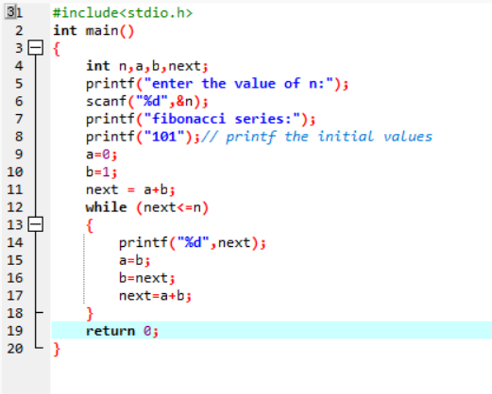
OUTPUT:

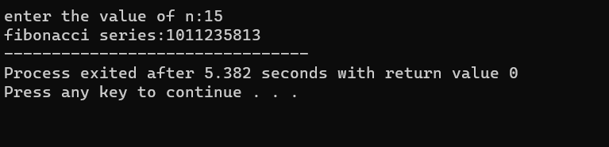

EXPERIMENT:5
EXPERIMENT NAME: SUMMING OF SERIES
PROGRAM:
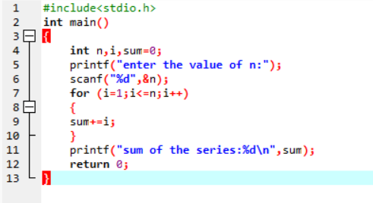
OUTPUT:

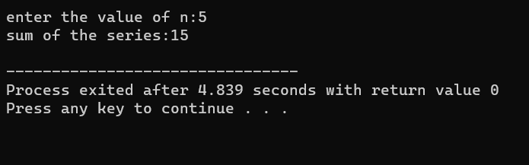

EXPERIMENT:6
EXPERIMENT NAME: SUMMING UP EVEN NUMBER SERIES
PROGRAM:
S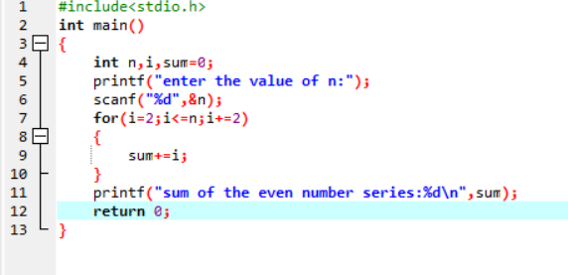
OUTPUT:
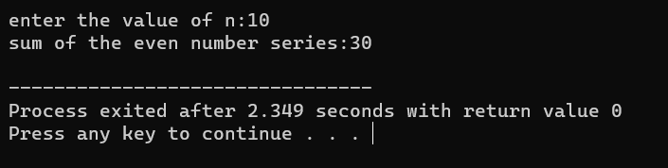

EXPERIMENT:7
EXPERIMENT NAME: SUMMING UP ODD NUMBER SERIES
PROGRAM:
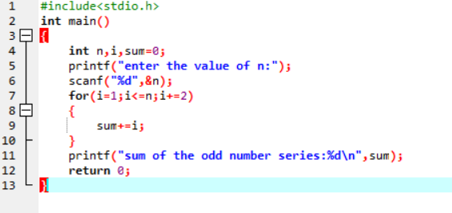
OUTPUT:

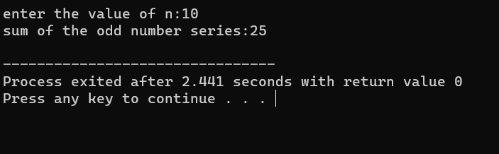

EXPERIMENT:8
EXPERIMENT NAME: SUMMING UP 1-2+3-4+5 ….. N
PROGRAM:
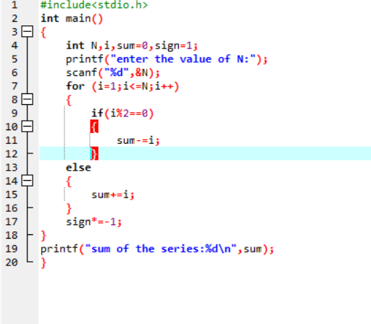
OUTPUT:
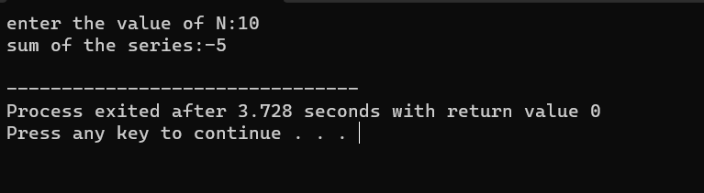

EXPERIMENT:9
EXPERIMENT NAME: SUMMING UP SQUARES OF NUMBERS
PROGRAM:
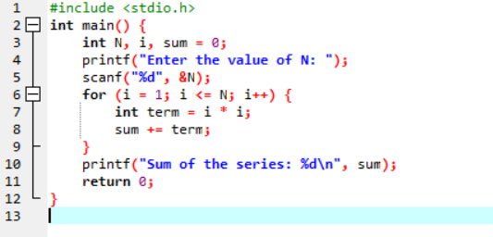

OUTPUT:
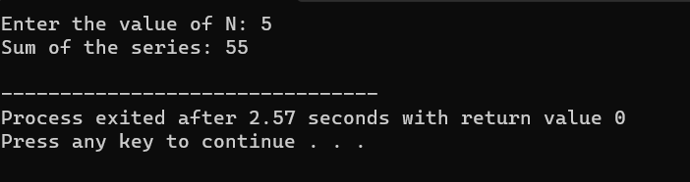

EXPERIMENT:10
EXPERIMENT NAME: SQUARES OF EVEN NUMBERS
PROGRAM:
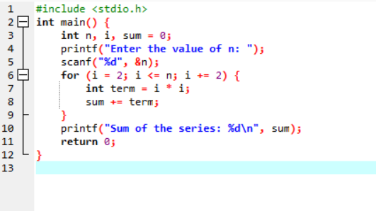
OUTPUT:
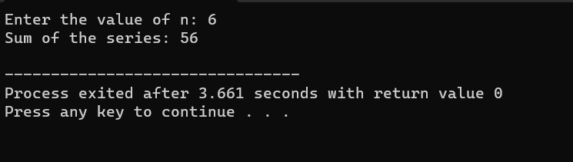

EXPERIMENT:11
EXPERIMENT NAME: Summing up 1¹+2²+3³+4⁴+ …. n^{n}
PROGRAM:

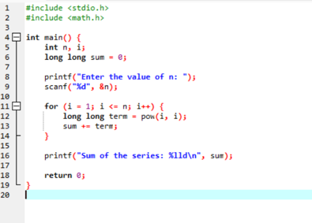
OUTPUT:

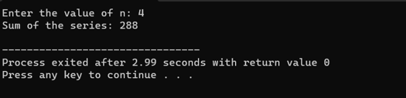

EXPERIMENT:12
EXPERIMENT NAME: Summing up squares of Odd numbers
PROGRAM:
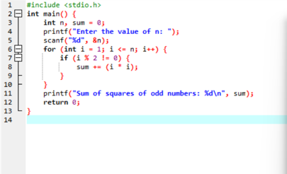

OUTPUT:

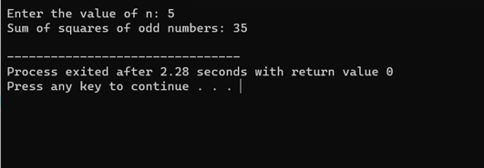

EXPERIMENT:13
EXPERIMENT NAME: Summing up cubes of n numbers
PROGRAM:
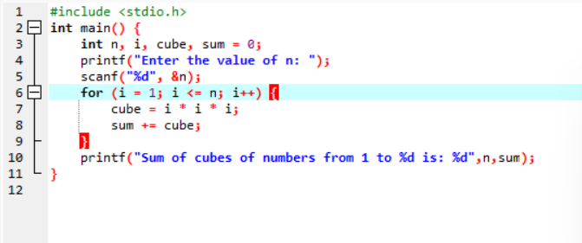

OUTPUT:
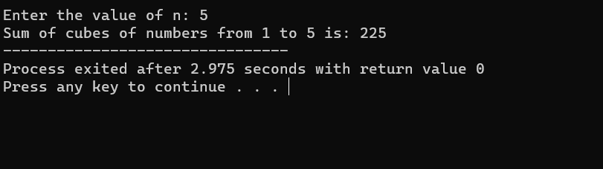

EXPERIMENT: 14
EXPERIMENT NAME: Product series (Factorial of a given number)
PROGRAM:

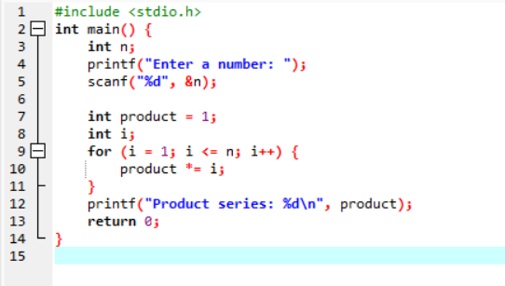
OUTPUT:
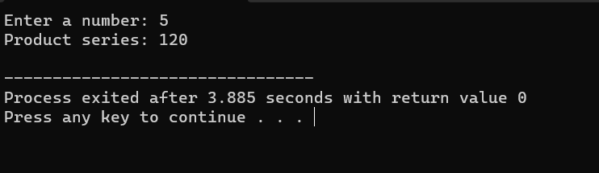

EXPERIMENT: 15
EXPERIMENT NAME: Finding given number is Armstrong or not
PROGRAM:
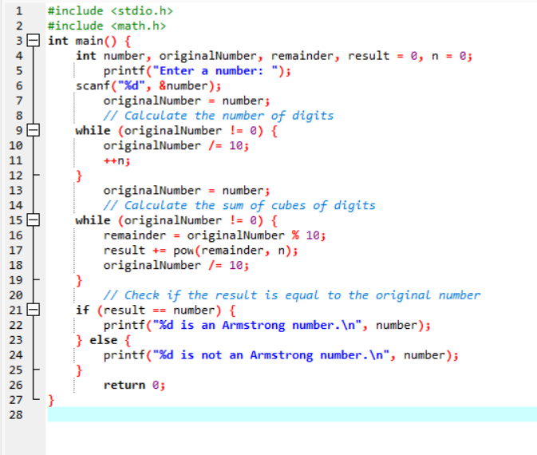

OTUPUT:
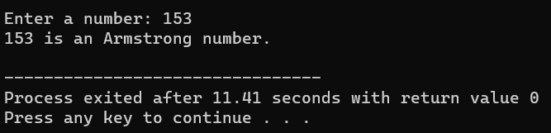
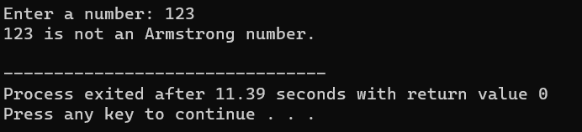

EXPERIMENT: 16
EXPERIMENT NAME: SUMMIMG UP ANY N NUMBERS AND FINDING AVERAGE
PROGRAM:

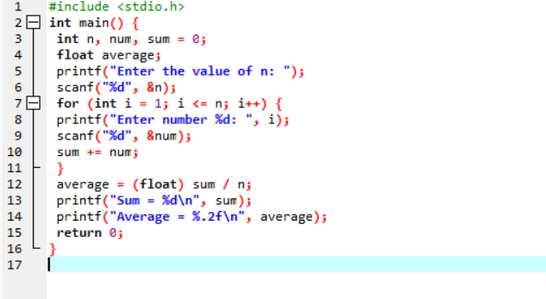
OUTPUT:

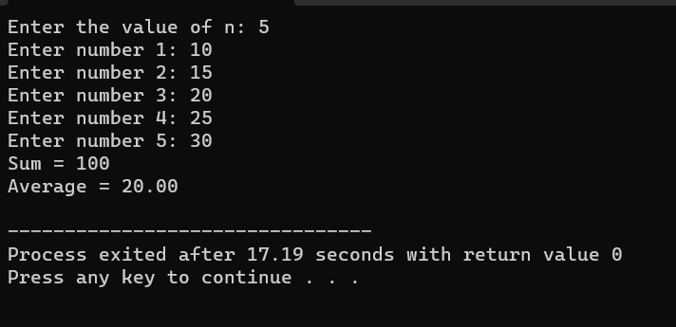

EXPERIMENT: 17
EXPERIMENT NAME: PRINTING DIGITS OF AN INTEGER NUMBER
PROGRAM:
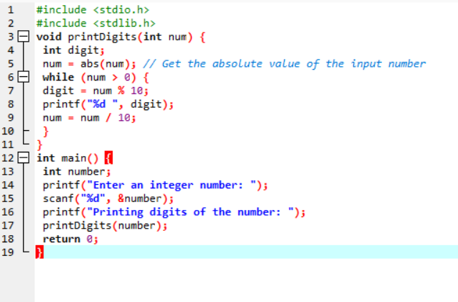

OUTPUT:

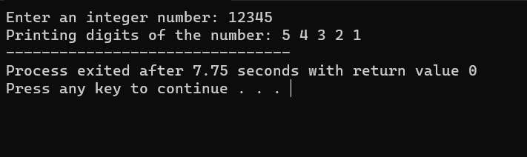

EXPERIMENT: 18
EXPERIMRNT NAME: SUMMING UP THE DIGITS OF AN INTEGER NUMBER
PROGRAM:
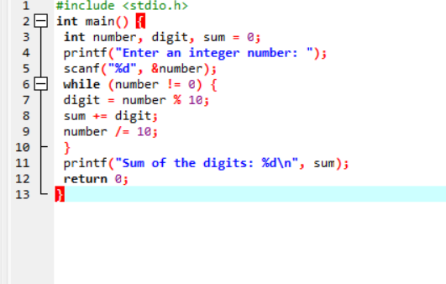

OUTPUT:
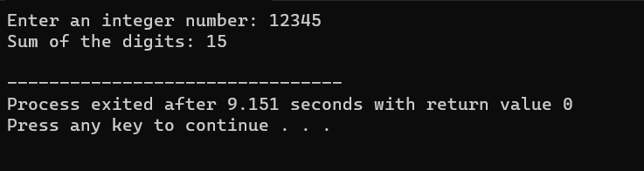

EXPERIMENT: 19
EXPERIMENT NAME: REVERSING THE DIGITS OF AN INTEGER NUMBER
PROGRAM:
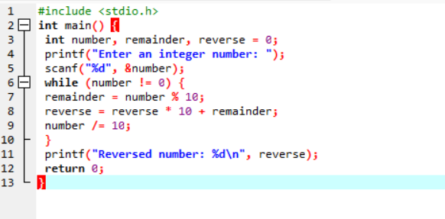
OUTPUT:
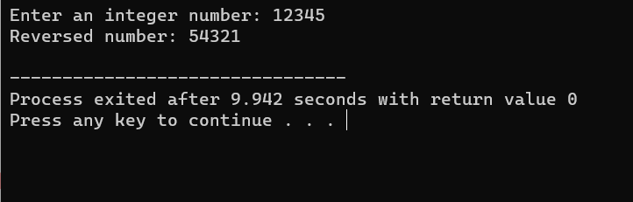

EXPERIMENT: 20
EXPERIMENT NAME: FINDING WHETHER THE GIVEN NUMBER INTEGER IS ODD OR EVEN
PROGRAM:
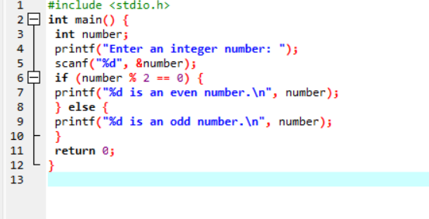

OUTPUT:
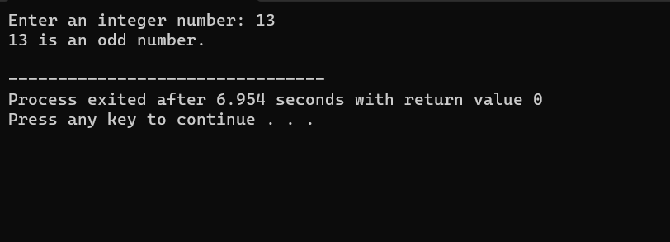

EXPERIMENT: 21
EXPERIMENT NAME:FINDING THE GIVEN INTEGER IS POSITIVE OR NEGATIVE
PROGRAM:
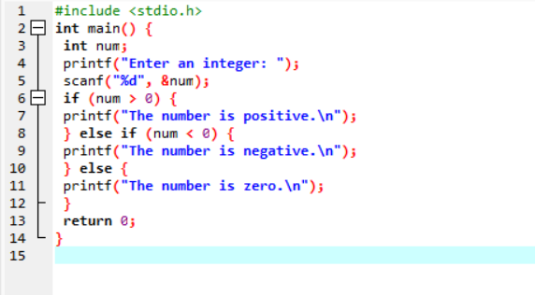

OUTPUT:
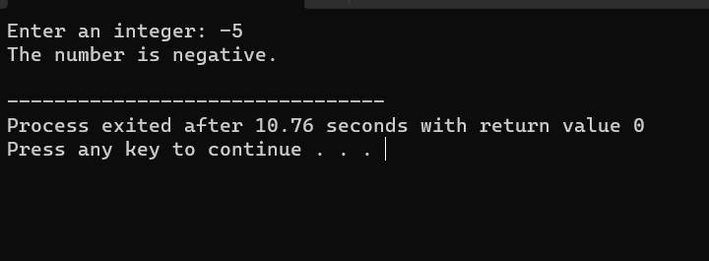

EXPERIMENT: 22
EXPERIMENT NAME:SWAPPING TWO NUMBERS WITH A TEMPORARY VARIABLE
PROGRAM:
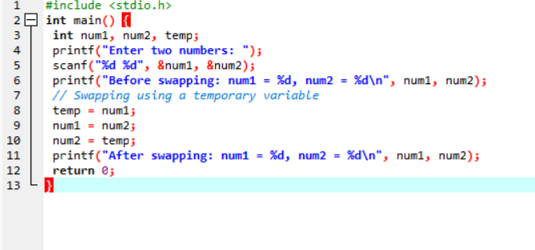

OUTPUT:
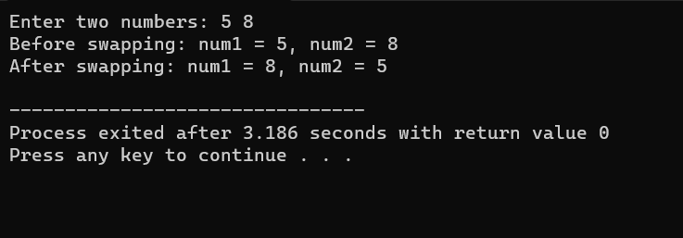

EXPERIMENT:23
EXPERIMENT NAME: SWAPPING TWO NUMBERS WITHOUT A TEMPORARY VARIABLE
PROGRAM:
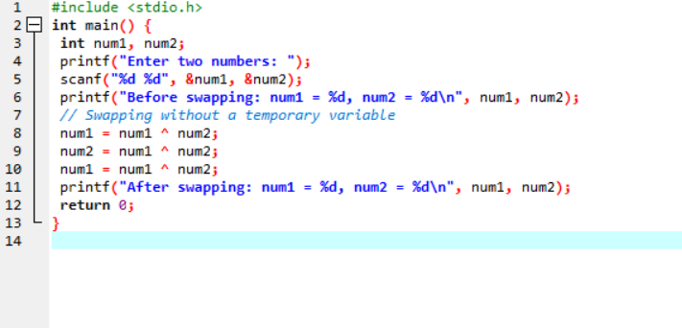

OUTPUT:
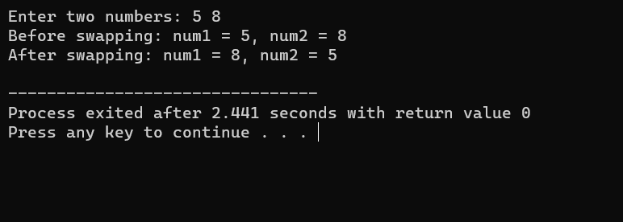

EXPERIMENT: 24
EXPERIMENT NAME: SWAP 3 NUMBERS A TO B,B TO C AND C TO A
PROGRAM:
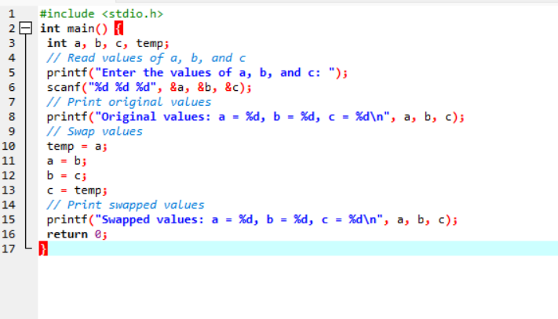

Output:
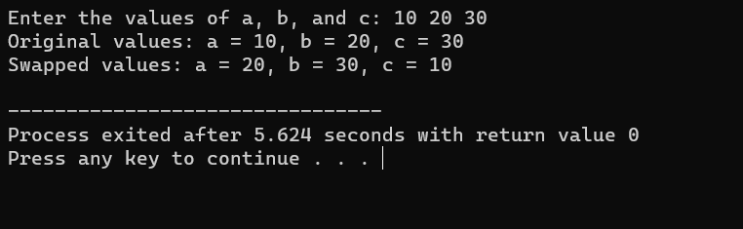

EXPERIMENT: 25
EXPERIMENT NAME: FINDING THE BIGGEST OUT OF 2 INTEGER NUMBER
PROGRAM:
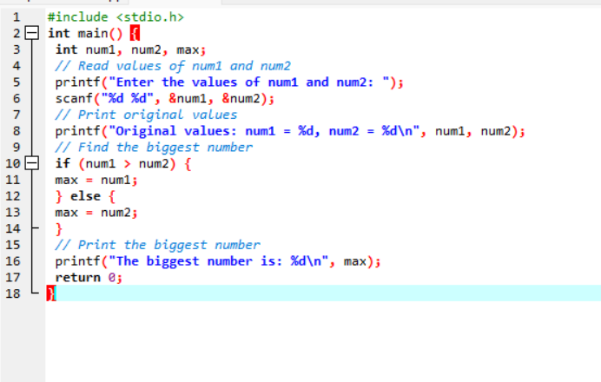

OUTPUT:
